**Supplementary Materials**

for “Thermodynamic Advantage of Transient Wave Dynamics in Hierarchical Decision Architectures”

Oleg Dolgikh • Draft v1.1 (FCN edit) • 2026-01-30

*Working draft. Sections and numbering may shift in revision; all metrics/definitions are stable.*

# Contents

Supplementary Methods

S1. Mathematical specification of CRN

S2. Datasets and graph construction

S3. Simulation protocol and metrics

S4. Baselines and negative controls

S5. Statistical analysis

Supplementary Results

S6. Universal DES across scales (conceptual figures)

S7. Drosophila larva connectome benchmark (A7)

S8. Localization diagnostics (A8.4)

S9. Architecture dependence and negative controls (A8.5–A8.6)

S10. Mouse cortical proxy: energy–selectivity trade-off (Steps 2–5)

S11. Evolutionary game‑theoretic selection for modular regime separation

Supplementary References

# Supplementary Methods

## S1. Mathematical specification of CRN

CRN (Coherent Resonant Netting) is defined as a two-stage decision architecture. Stage‑I performs a low‑amplitude, wave‑like exploration that prunes a hypothesis space at low marginal cost, and Stage‑II corresponds to a high‑gain commitment/readout mechanism (e.g., spiking fixation) that acts on the pruned set. In this Supplementary Materials we formalize Stage‑I as an open-system wave proxy and evaluate its functional outputs via absorption into Target vs Distractor sinks.

### S1.1 Graph and state space

Let G=(V,E) be a directed graph with |V|=N nodes and weighted edges w_{ij}≥0. Stage‑I dynamics are represented by a density matrix ρ(t) on an N‑dimensional state space {|i⟩}. The diagonal ρ_{ii}(t) is interpreted as node occupancy probability (population proxy).

Baseline Hamiltonian from a symmetrized weighted Laplacian:

H0 = -γ · L_sym, where L_sym = D_sym - W_sym, W_sym = (W + Wᵀ)/2.

### S1.2 Open-system dynamics (GKSL proxy)

Stage‑I is modeled with the GKSL master equation with dephasing and absorbing sinks. GKSL is used as a functional proxy for transient wave dynamics with tunable decoherence/measurement, not as a claim of microscopic quantum coherence in neural tissue.

dρ/dt = -i [H, ρ] + κ · Σ_k (|k⟩⟨k| ρ |k⟩⟨k| - ½ { |k⟩⟨k|, ρ}) + Σ_{s∈S} η_s · (J_s ρ J_s† - ½ {J_s† J_s, ρ }).

κ controls the coherence–measurement balance (κ→0: coherent exploration; κ≫1: Zeno-like classicalization). Sinks are implemented by jump operators J_s that remove population from designated nodes into external accumulators (Target vs Distractor).

### S1.3 Disorder parameter ε

Energetic heterogeneity is modeled as diagonal disorder:

H = H0 + diag(E), with E_i ~ Uniform[-ε, +ε].

### S1.4 Metrics

At T_end we report sink absorption probabilities P_T (Target) and P_D (Distractor), and define:

Selectivity_end = P_T / (P_D + δ), coverage_end = P_T + P_D.

Utility(λ) = P_T − λ·P_D, InfoPerCost = Utility(λ) / (coverage_end + χ).

P_good = Pr(Selectivity_end > θ | P_T > pT_min).

*Unless stated otherwise: λ=1, χ=0.01, θ=2.0, pT_min=0.005.*

## S2. Datasets and graph construction

### S2.1 C. elegans touch circuit

A small C. elegans subcircuit (touch → interneurons → motor outputs) derived from Varshney et al. is used as a minimal connectome benchmark. Nodes are grouped into sensory sources, target motor outputs, and distractor outputs. The task is formulated as absorption into target vs distractor sinks.

### S2.2 Drosophila larva mushroom body (Winding et al. 2023)

A directed weighted graph is built from the larval Drosophila connectome (Winding et al., Science 2023). We extract an MB-centered subgraph and an active subgraph connecting selected PN sources to MBON sinks.

**Table S1. Drosophila graph sizes used in Bridge‑A.**

|  |  |  |
| --- | --- | --- |
| Graph | nodes | edges |
| core MB subgraph | 379 | 2137 |
| extended MB subgraph | 553 | 3875 |
| active subgraph (core) | 80 | 381 |
| active subgraph (extended) | 243 | 1765 |

Extended-graph benchmark selection sizes: PN sources=10, MBON targets=5, MBON distractors=5.

### S2.3 Mouse cortical proxy (SBM)

A stochastic block model with hierarchical feed-forward structure is used as a mouse cortical proxy to probe scalability and the permeability–selectivity trade-off.

## S3. Simulation protocol and default parameters

Unless stated otherwise we use γ=1.0, η_sink=1.0, dt=0.05, T_end=10.0. Each condition is evaluated over multiple disorder draws and, where applicable, multiple surrogate graphs.

**Table S2. Key numerical parameters (Drosophila benchmark config).**

|  |  |
| --- | --- |
| parameter | value |
| gamma | 1.0 |
| eta_sink | 1.0 |
| dt | 0.05 |
| T_max/T_end | 10.0 |
| kappa_grid | 0.001, 0.003, 0.01, 0.03, 0.1, 0.3, 1.0, 3.0, 10.0 |

## S4. Baselines and negative controls

Baselines include a classical random walk (CRW) and a thermal random walk in the same energy landscape at T_env∈{0.1,1.0}. Negative controls include degree-preserving rewiring within edge types and partial lesions of KC→MBON projections.

## S5. Statistical analysis

We report two-way ANOVA for main effects of architecture variant and disorder ε on Selectivity_end and coverage_end, and bootstrap confidence intervals for the DES effect Δ(ε=3−ε=0) within each architecture. Between-architecture comparisons bootstrap the difference in DES magnitudes.

# Supplementary Results

## S6. Universal DES across scales (conceptual figures)

These figures are used in the main text to anchor the Two‑Factor Mechanism and the cross-scale DES claim.

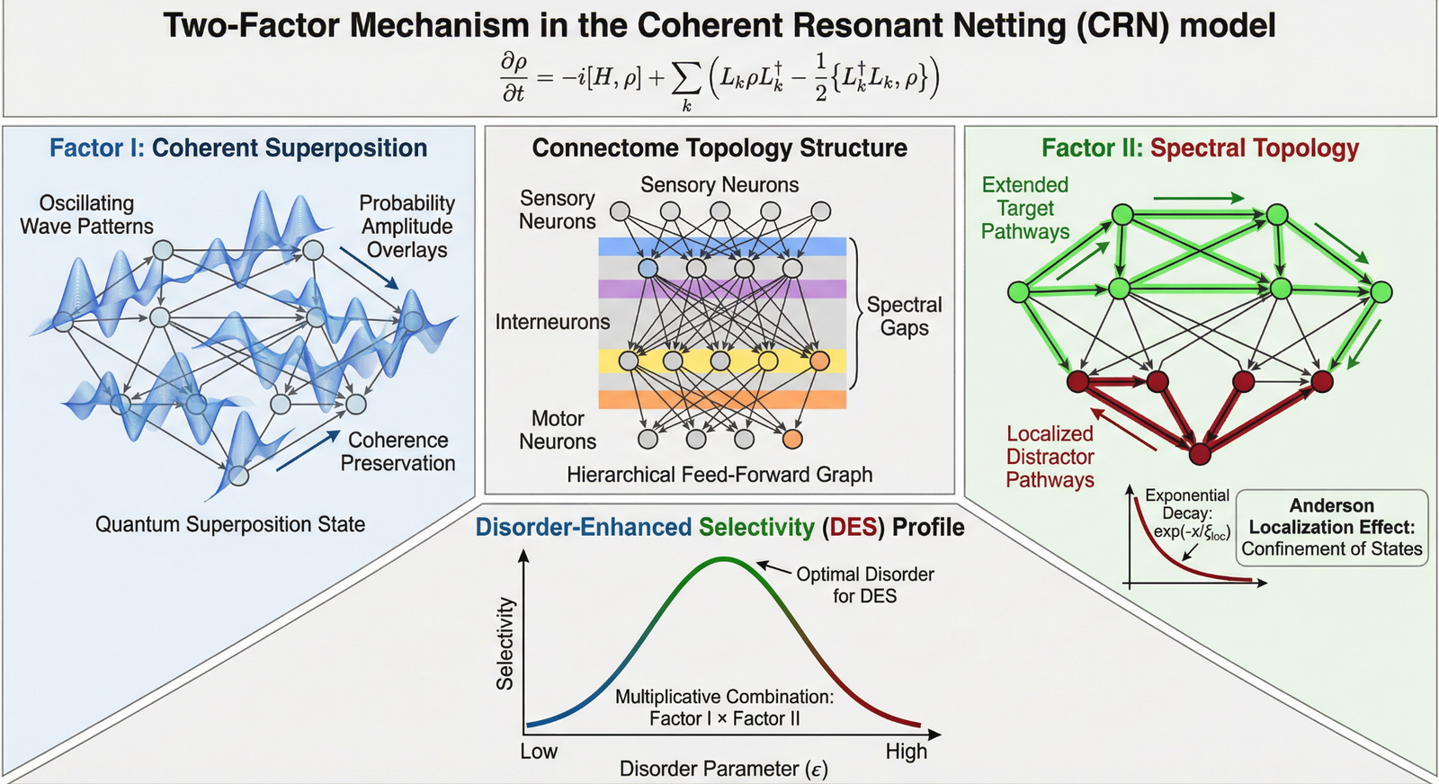

*Supplementary Figure S1. Two‑Factor Mechanism schematic (Factor I: coherence proxy; Factor II: spectral topology).*

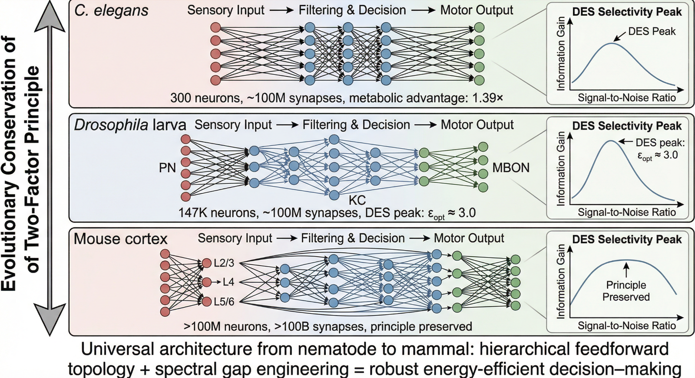

*Supplementary Figure S2. Universal hierarchical decision architecture schematic across scales (nematode → insect → mammal).*

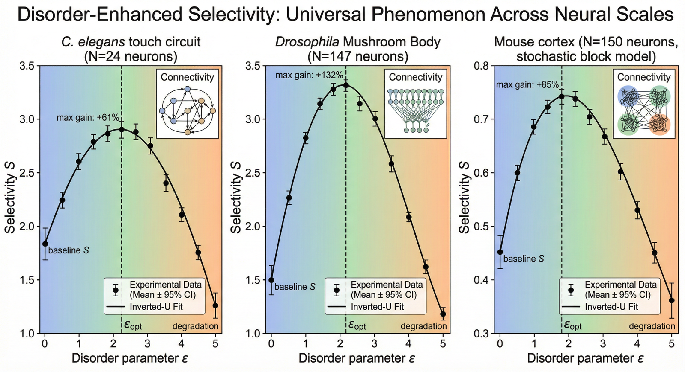

*Supplementary Figure S3. Disorder‑Enhanced Selectivity (DES) across three substrates (C. elegans, Drosophila, mouse proxy).*

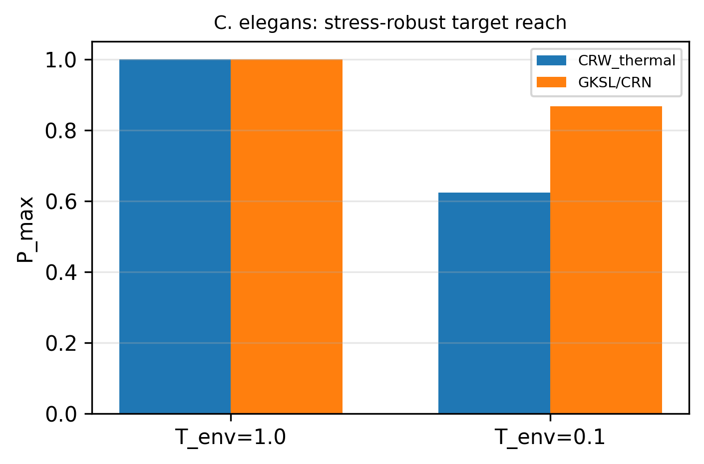

*Supplementary Figure S4. C. elegans touch circuit: maximum target absorption P_max at T_env=1.0 and T_env=0.1 for the wave proxy vs thermal baseline.*

## S7. Drosophila larva connectome benchmark (A7)

Table S3 summarizes best-by-objective GKSL performance as a function of disorder ε, alongside CRW and thermal baselines. Note: for ε=5, the best-by-selectivity metric is undefined under the minimum-throughput filter used in the sweep.

**Table S3. A7 compact summary (Drosophila benchmark).**

|  |  |  |  |  |  |  |  |  |  |  |  |  |  |
| --- | --- | --- | --- | --- | --- | --- | --- | --- | --- | --- | --- | --- | --- |
| eps | k_sel | Sel_GKSL | cov_GKSL | PT_GKSL | PD_GKSL | k_IPC | IPC_GKSL | Sel_CRW | IPC_CRW | Sel_T0.1 | IPC_T0.1 | Sel_T1.0 | IPC_T1.0 |
| 0 | 1 | 1.52 | 0.0122 | 0.007357 | 0.00484 | 1 | 0.1134 | 0.8783 | -0.06352 | 0.8783 | -0.06352 | 0.8783 | -0.06352 |
| 1 | 1 | 1.558 | 0.009416 | 0.005736 | 0.00368 | 1 | 0.1058 | 0.8783 | -0.06352 | 0.9071 | -0.04691 | 0.9752 | -0.0123 |
| 2 | 0.3 | 1.544 | 0.008445 | 0.005125 | 0.00332 | 1 | 0.1064 | 0.8783 | -0.06352 | 1.274 | 0.1157 | 0.9368 | -0.03187 |
| 3 | 0.001 | 2.224 | 0.007904 | 0.005452 | 0.002452 | 0.001 | 0.1676 | 0.8783 | -0.06352 | 1.252 | 0.1066 | 1.037 | 0.01762 |
| 5 |  |  |  |  |  | 1 | 0.06066 | 0.8783 | -0.06352 | 1.167 | 0.07357 | 0.983 | -0.008244 |

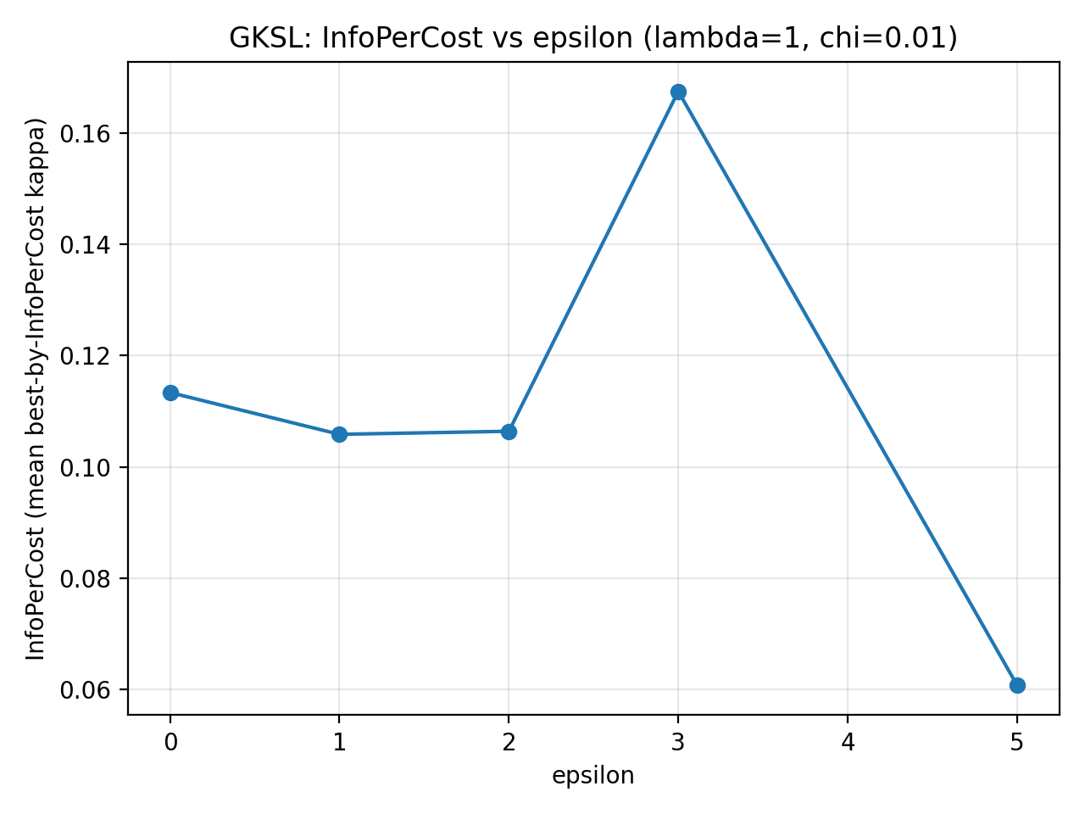

*Supplementary Figure S5. Best-by-InfoPerCost across disorder ε (A7).*

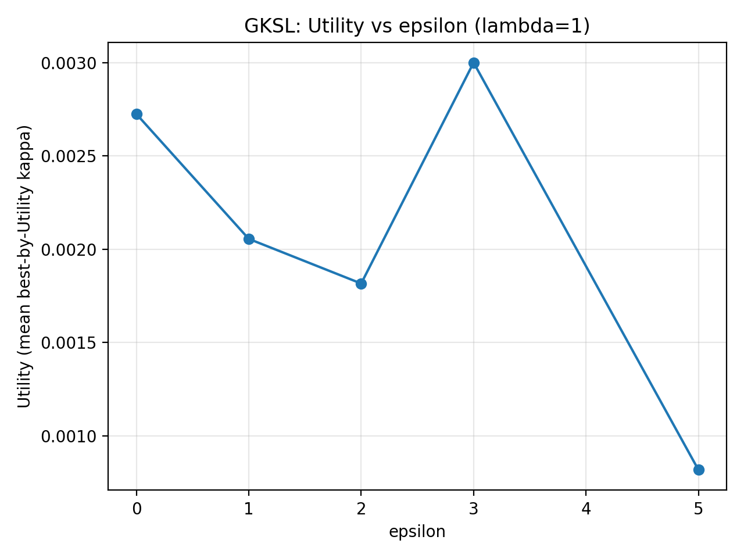

*Supplementary Figure S6. Best-by-Utility across disorder ε (A7).*

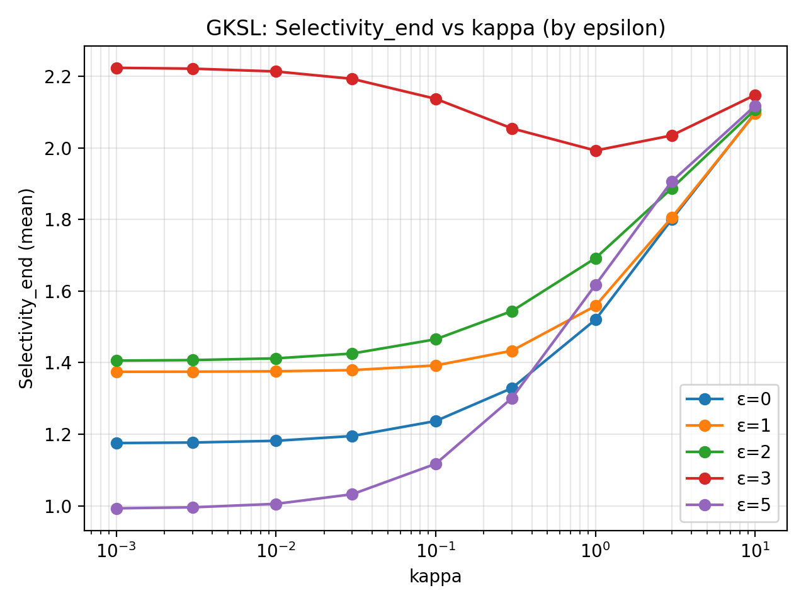

*Supplementary Figure S7. Selectivity_end vs κ for multiple ε (A7).*

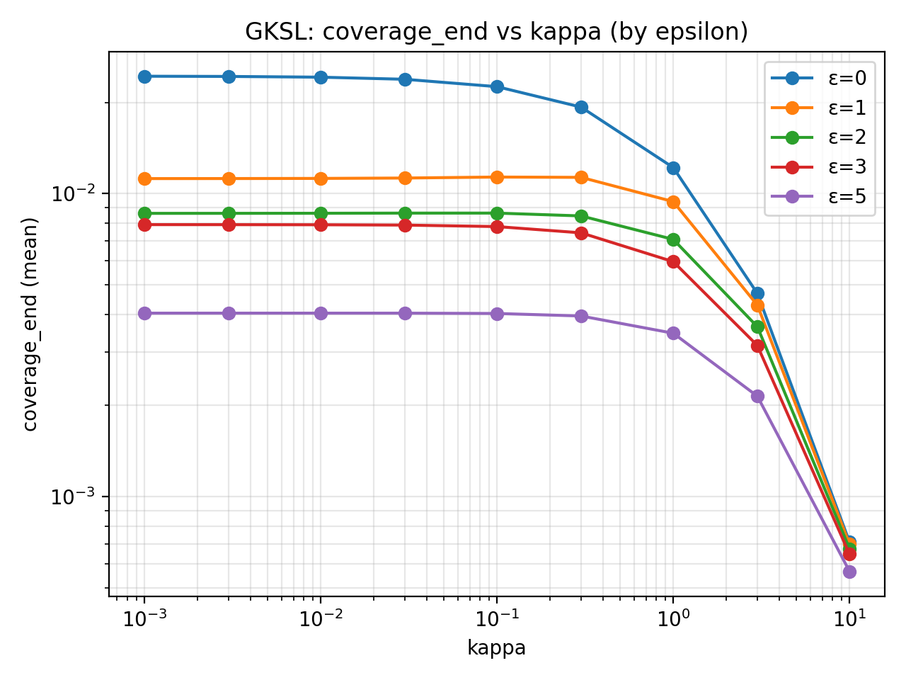

*Supplementary Figure S8. coverage_end vs κ for multiple ε (A7).*

## S8. Localization diagnostics (A8.4)

We report participation-ratio diagnostics and differential localization ΔPR = PR_target − PR_distractor.

**Table S4. Localization diagnostics by ε (κ=0.001).**

|  |  |  |  |  |  |  |  |
| --- | --- | --- | --- | --- | --- | --- | --- |
| epsilon | n_trials | Selectivity_end_mean | Selectivity_end_std | delta_PR_mean | delta_PR_std | ratio_PR_mean | ratio_PR_std |
| 0 | 10 | 1.175 | 0 | -1.961 | 2.341e-16 | 0.6072 | 0 |
| 1 | 10 | 1.408 | 0.3943 | -0.7682 | 1.175 | 0.7978 | 0.3145 |
| 2 | 10 | 1.687 | 0.8646 | -0.1843 | 0.5956 | 0.9599 | 0.1628 |
| 3 | 10 | 3.524 | 4.945 | -0.09162 | 1.232 | 1.054 | 0.4415 |
| 5 | 10 | 1.361 | 1.249 | 0.05169 | 1.045 | 1.082 | 0.4161 |

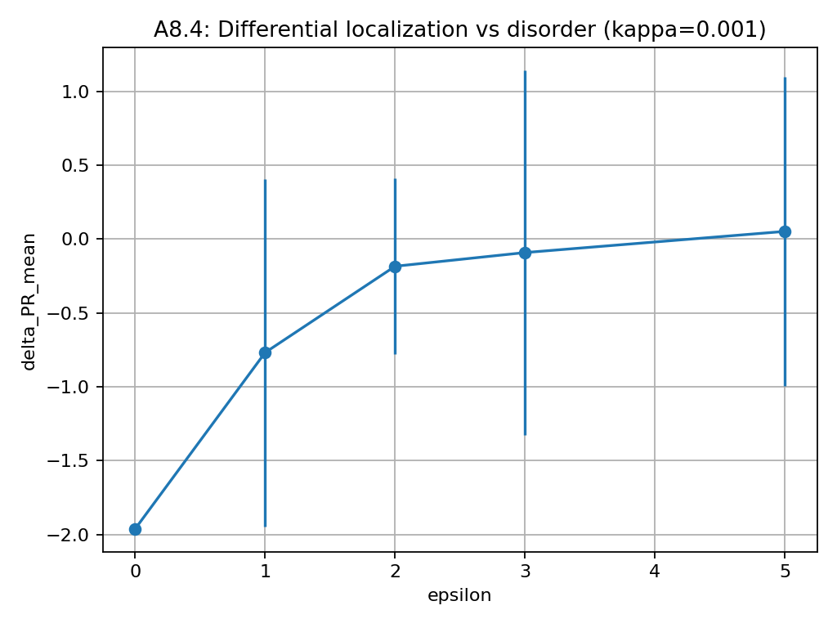

*Supplementary Figure S9. ΔPR vs ε at κ=0.001 (A8.4).*

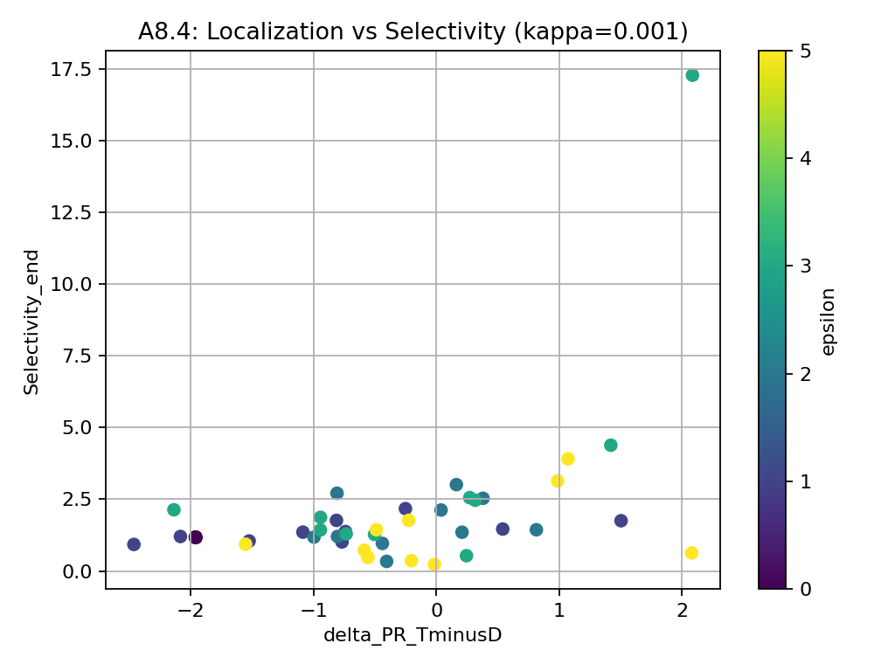

*Supplementary Figure S10. Selectivity_end vs ΔPR scatter (A8.4).*

## S9. Architecture dependence and negative controls (A8.5–A8.6)

Two-way ANOVA and bootstrap tests quantify architecture × disorder effects and the DES peak dependency on topology.

**Table S5. Two-way ANOVA (κ=0.001).**

|  |  |  |  |  |  |
| --- | --- | --- | --- | --- | --- |
| Metric | Effect | F | df1 | df2 | p_value |
| Selectivity_end | VARIANT | 44.7 | 2 | 4097 | 6.25e-20 |
| Selectivity_end | EPSILON | 31.12 | 4 | 4095 | 1.45e-25 |
| Selectivity_end | ALL_CELLS | 20.53 | 14 | 4085 | 4.16e-51 |
| coverage_end | VARIANT | 14.33 | 2 | 4097 | 6.28e-07 |
| coverage_end | EPSILON | 2907 | 4 | 4095 | <1e-300 |
| coverage_end | ALL_CELLS | 932.4 | 14 | 4085 | <1e-300 |

**Table S6. Bootstrap DES within variants (κ=0.001).**

|  |  |  |  |  |  |
| --- | --- | --- | --- | --- | --- |
| variant | contrast | delta | CI_low | CI_high | significance |
| lesion_KC_MBON | DES = Selectivity_end(ε=3) - Selectivity_end(ε=0) | 1.102 | 0.83 | 1.398 | significant |
| lesion_KC_MBON | Selectivity_end(ε=3) - Selectivity_end(ε=5) | -0.502 | -0.832 | -0.188 | significant |
| original | DES = Selectivity_end(ε=3) - Selectivity_end(ε=0) | 1.489 | 0.249 | 3.355 | significant |
| original | Selectivity_end(ε=3) - Selectivity_end(ε=5) | -0.898 | -2.805 | 0.491 | ns |
| rewired_type | DES = Selectivity_end(ε=3) - Selectivity_end(ε=0) | 0.162 | 0.056 | 0.274 | significant |
| rewired_type | Selectivity_end(ε=3) - Selectivity_end(ε=5) | 0.436 | 0.21 | 0.672 | significant |

**Table S7. Bootstrap DES between variants (κ=0.001).**

|  |  |  |  |  |
| --- | --- | --- | --- | --- |
| contrast | delta | CI_low | CI_high | significance |
| DES(original) - DES(rewired_type) | 1.328 | 0.069 | 3.232 | p<0.001 |
| DES(original) - DES(lesion_KC_MBON) | 0.383 | -0.902 | 2.261 | ns |
| DES(lesion_KC_MBON) - DES(rewired_type) | 0.938 | 0.646 | 1.254 | p<0.001 |

**Table S8. Architecture dependence metrics (κ=0.001).**

|  |  |  |  |  |  |  |  |
| --- | --- | --- | --- | --- | --- | --- | --- |
| variant | epsilon | n_runs_total | mean_P_sink_T_end | mean_P_sink_D_end | Selectivity_end_mean | Selectivity_ratioOfMeans | coverage_end_mean |
| lesion_KC_MBON | 0 | 400 | 0.01647 | 0.01396 | 1.194 | 1.18 | 0.03042 |
| lesion_KC_MBON | 1 | 400 | 0.009295 | 0.007022 | 1.454 | 1.324 | 0.01632 |
| lesion_KC_MBON | 2 | 400 | 0.007125 | 0.004964 | 1.702 | 1.435 | 0.01209 |
| lesion_KC_MBON | 3 | 400 | 0.006401 | 0.003987 | 2.296 | 1.605 | 0.01039 |
| lesion_KC_MBON | 5 | 400 | 0.002816 | 0.002368 | 1.795 | 1.189 | 0.005184 |
| original | 0 | 20 | 0.01319 | 0.01122 | 1.175 | 1.175 | 0.02441 |
| original | 1 | 20 | 0.006436 | 0.005012 | 1.362 | 1.284 | 0.01145 |
| original | 2 | 20 | 0.00472 | 0.003596 | 1.569 | 1.312 | 0.008316 |
| original | 3 | 20 | 0.004564 | 0.002589 | 2.662 | 1.763 | 0.007153 |
| original | 5 | 20 | 0.002089 | 0.00156 | 1.762 | 1.339 | 0.003649 |
| rewired_type | 0 | 400 | 0.0126 | 0.01254 | 1.062 | 1.005 | 0.02515 |
| rewired_type | 1 | 400 | 0.008359 | 0.008874 | 1.113 | 0.9419 | 0.01723 |
| rewired_type | 2 | 400 | 0.006022 | 0.006077 | 1.255 | 0.991 | 0.0121 |
| rewired_type | 3 | 400 | 0.004412 | 0.004895 | 1.225 | 0.9014 | 0.009307 |
| rewired_type | 5 | 400 | 0.002553 | 0.002638 | 1.659 | 0.9681 | 0.005191 |

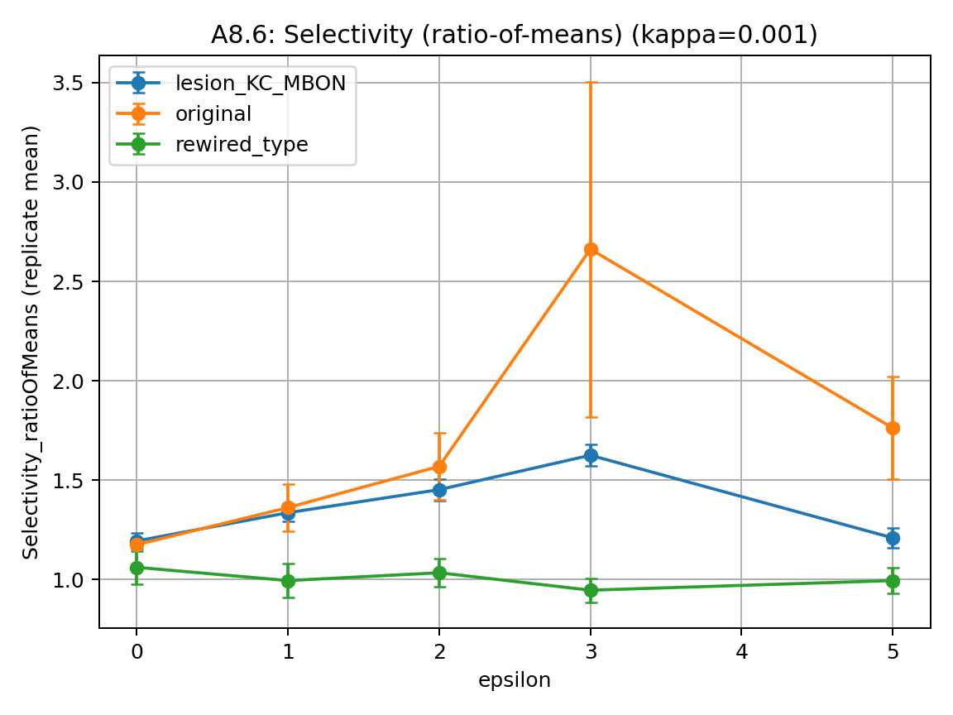

*Supplementary Figure S11. Selectivity ratio-of-means vs ε at κ=0.001 (A8.6).*

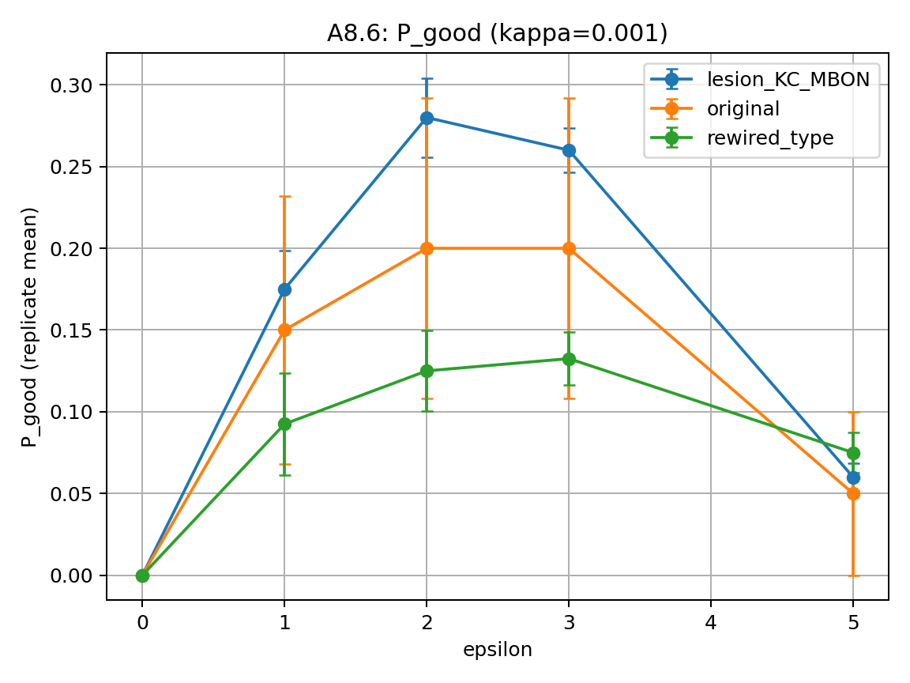

*Supplementary Figure S12. P_good vs ε at κ=0.001 (θ=2.0, pT_min=0.005).*

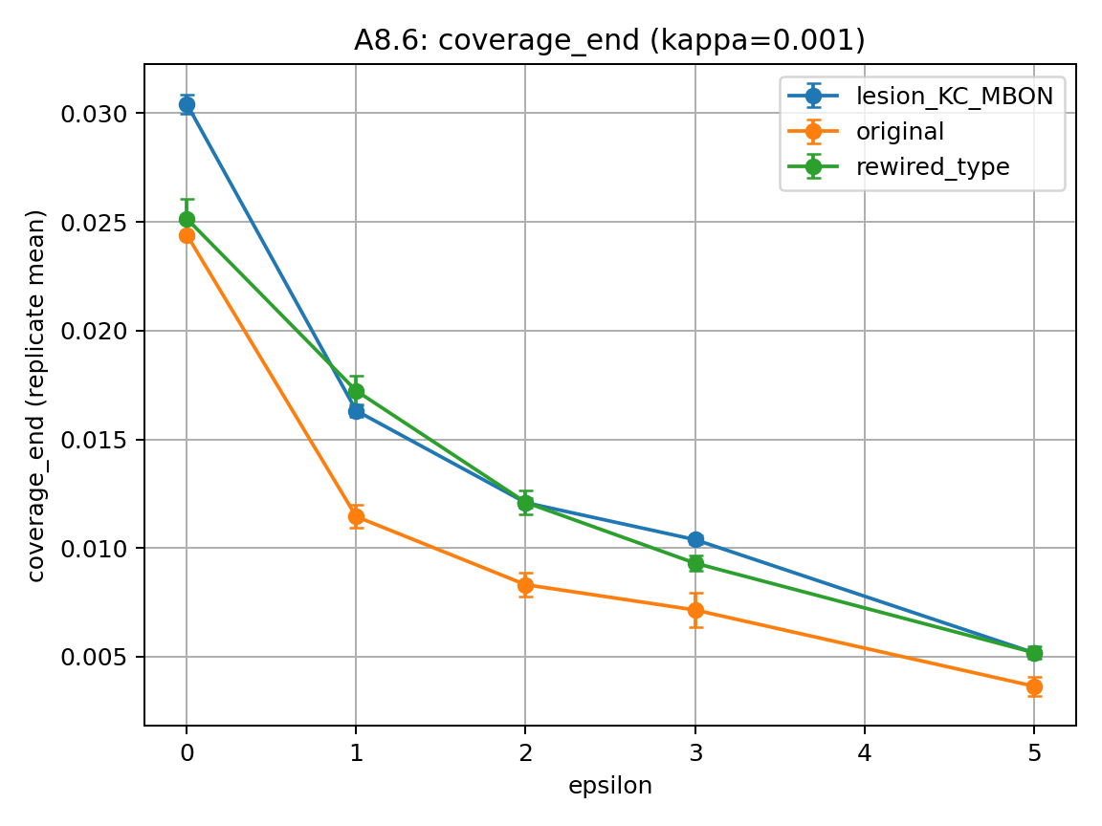

*Supplementary Figure S13. coverage_end vs ε at κ=0.001 (A8.6).*

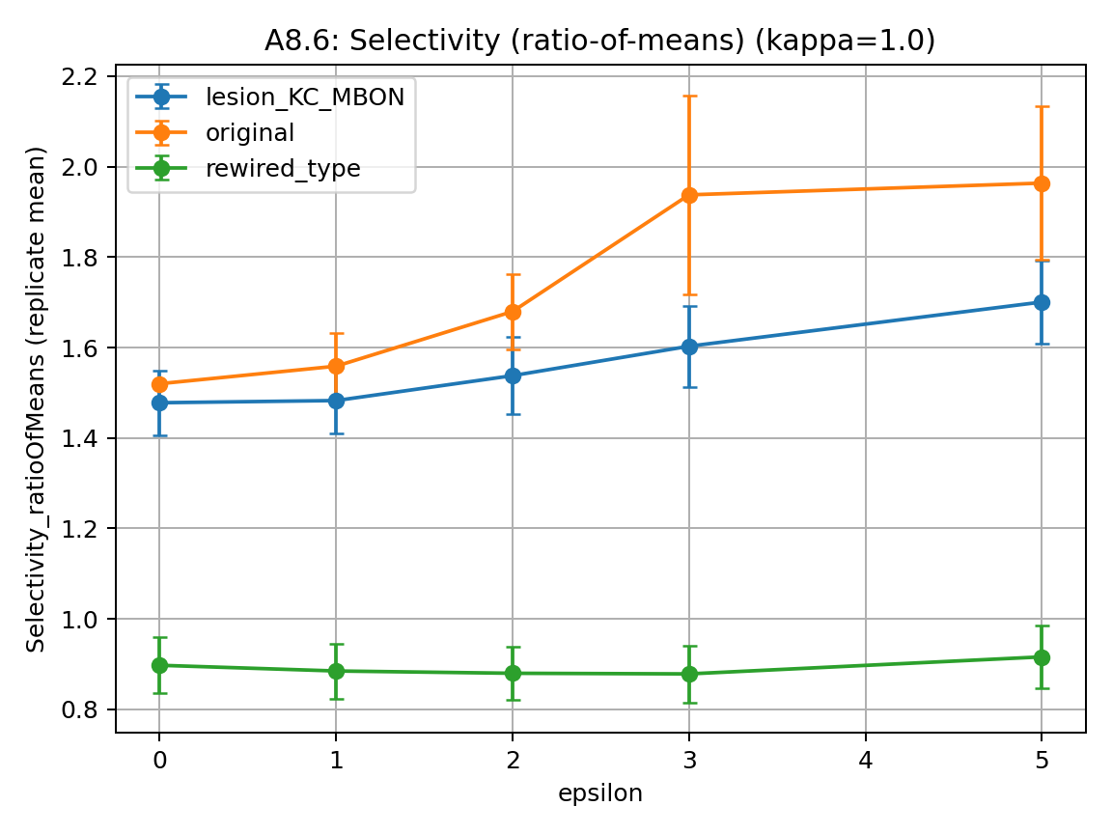

*Supplementary Figure S14. Selectivity ratio-of-means vs ε at κ=1.0 (A8.6).*

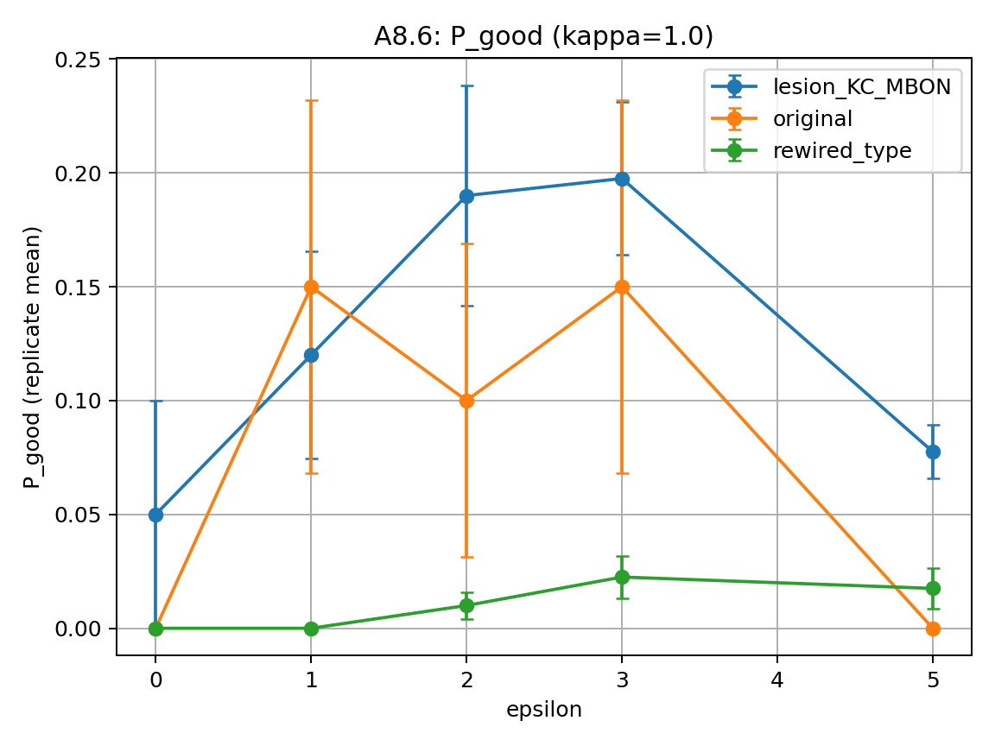

*Supplementary Figure S15. P_good vs ε at κ=1.0 (θ=2.0, pT_min=0.005).*

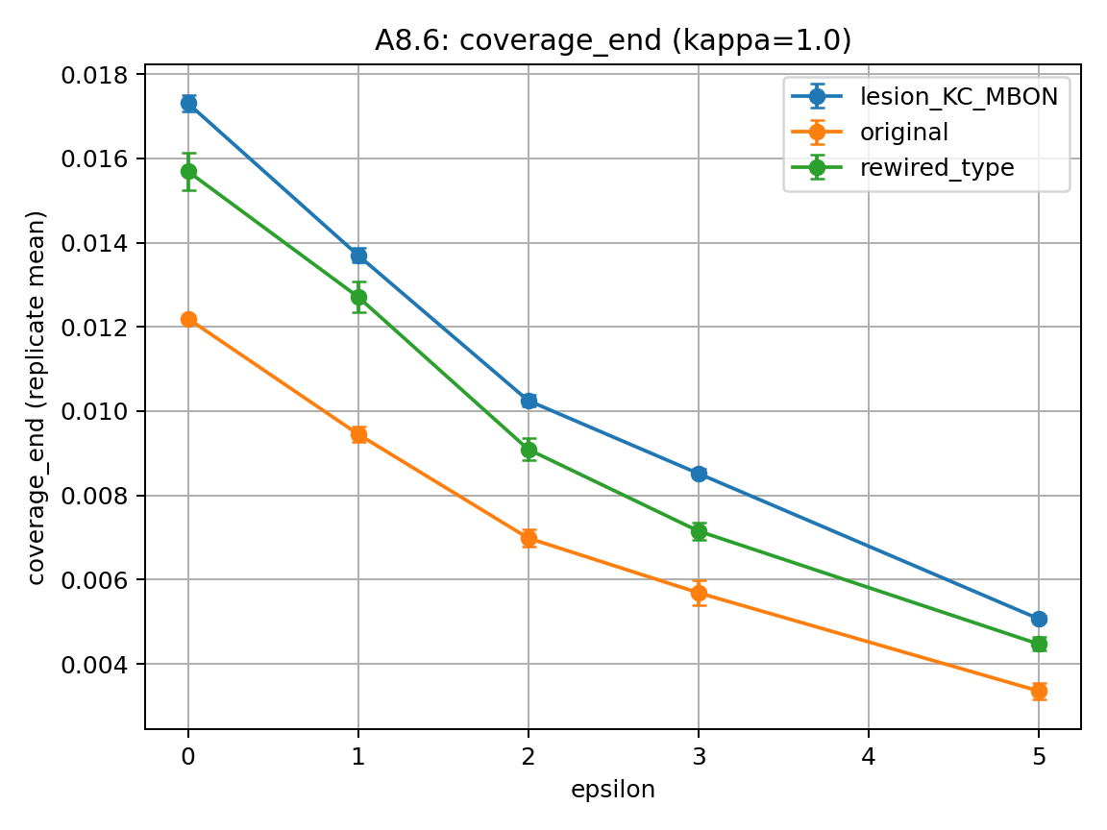

*Supplementary Figure S16. coverage_end vs ε at κ=1.0 (A8.6).*

## S10. Mouse cortical proxy: energy–selectivity trade-off (Steps 2–5)

Summary tables from Steps 2–3 are reproduced below; an additional phase diagram is shown in Figures S17–S18.

**Table S9. Cortex proxy transport summary (Step2).**

|  |  |  |  |  |  |  |  |  |
| --- | --- | --- | --- | --- | --- | --- | --- | --- |
| T_env | n | recall_mean | recall_std | recall_ci95 | leakage_mean | leakage_std | leakage_ci95 | selectivity_ratio_of_means |
| 0.1 | 100 | 0.4797 | 0.2356 | 0.04619 | 0.3998 | 0.2139 | 0.04193 | 1.2 |
| 1 | 100 | 0.2751 | 0.05368 | 0.01052 | 0.6574 | 0.05673 | 0.01112 | 0.4185 |
| inf | 100 | 0.2667 | 4.898e-15 | 9.6e-16 | 0.6667 | 1.223e-14 | 2.398e-15 | 0.4 |

**Table S10. Cortex proxy memory summary (Step3).**

|  |  |  |  |  |  |  |  |  |
| --- | --- | --- | --- | --- | --- | --- | --- | --- |
| T_env | n | recall_mean | recall_ci95 | leakage_mean | leakage_ci95 | selectivity_ratio_of_means | recall_frac_mean | recall_minus_leakage_mean |
| 0.01 | 20 | 0.5674 | 0.08386 | 0.2754 | 0.06837 | 2.06 | 0.6787 | 0.292 |
| 0.05 | 20 | 0.5644 | 0.09484 | 0.2898 | 0.07687 | 1.947 | 0.6597 | 0.2746 |
| 0.1 | 20 | 0.4742 | 0.08977 | 0.4089 | 0.09207 | 1.16 | 0.543 | 0.06529 |
| 0.2 | 20 | 0.3221 | 0.05987 | 0.5979 | 0.07434 | 0.5387 | 0.3554 | -0.2758 |
| 0.5 | 20 | 0.2721 | 0.02415 | 0.6583 | 0.02757 | 0.4133 | 0.2925 | -0.3862 |
| 1 | 20 | 0.274 | 0.01684 | 0.6546 | 0.01968 | 0.4186 | 0.2952 | -0.3806 |
| 2 | 20 | 0.2708 | 0.009924 | 0.6589 | 0.01226 | 0.4109 | 0.2913 | -0.3881 |
| 5 | 20 | 0.2678 | 0.004121 | 0.6638 | 0.005326 | 0.4035 | 0.2875 | -0.3959 |
| 10 | 20 | 0.2671 | 0.002057 | 0.6653 | 0.002695 | 0.4014 | 0.2865 | -0.3982 |
| inf | 20 | 0.2667 | 1.849e-15 | 0.6667 | 4.622e-15 | 0.4 | 0.2857 | -0.4 |

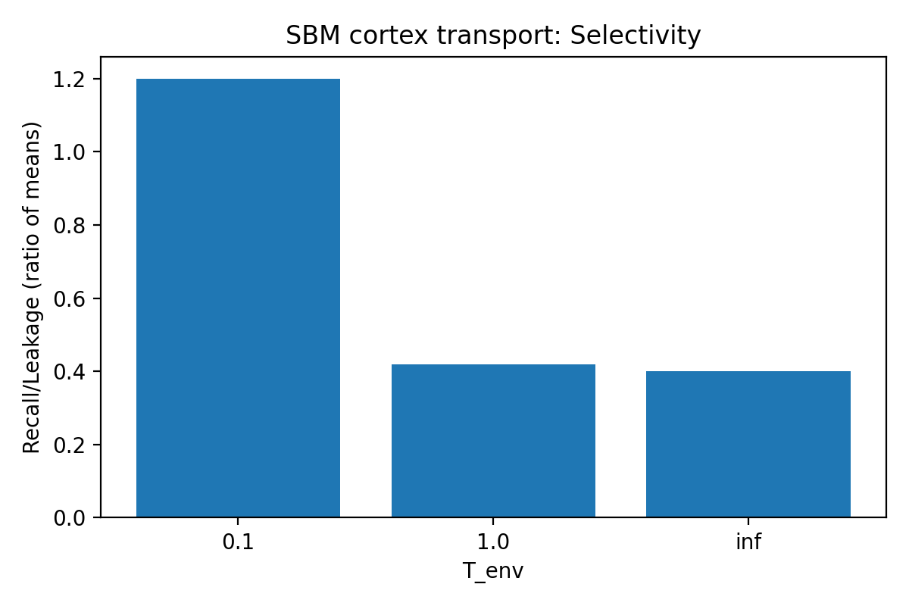

*Supplementary Figure S17. Selectivity vs T_env (Step2).*

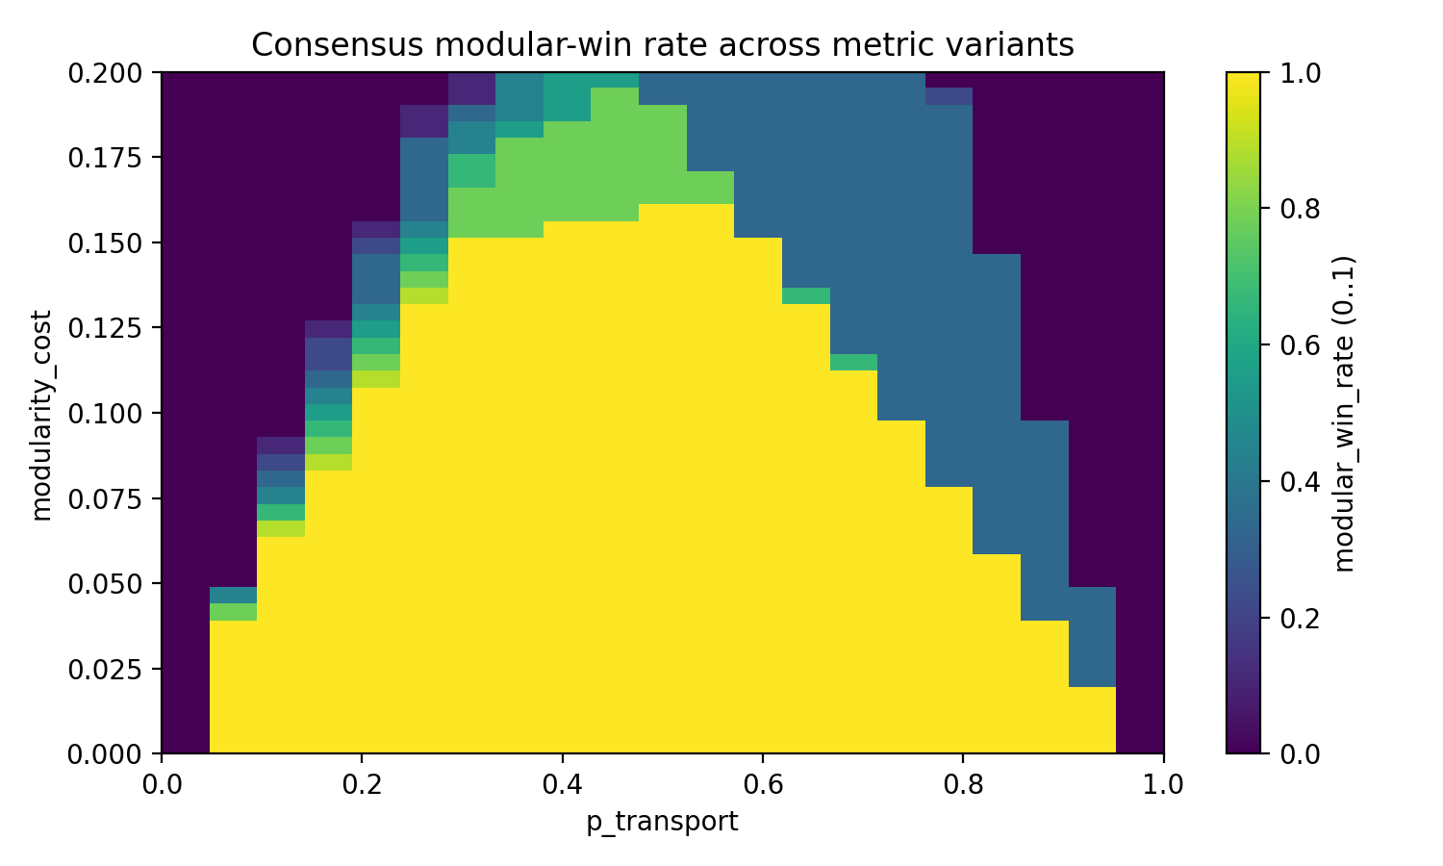

*Supplementary Figure S18. Consensus phase diagram in (κ, Δ) space (Step5 robustness audit).*

S11. Evolutionary game‑theoretic selection for modular regime separation

This section summarizes an auxiliary evolutionary game‑theoretic analysis designed to test whether modular separation of noise regimes (a transport‑optimized module versus a memory‑optimized module) is a plausible outcome of selection under mixed task demands.

Setup. We consider two objective classes: (i) fast transport/selection on a disordered substrate, which in the cortex‑proxy transport benchmark is optimized at intermediate dephasing (κ≈0.5), and (ii) memory/retention, which is optimized at much lower dephasing (κ≈0.01) to minimize leakage and preserve attractor stability. Strategies compete either as global controls (single κ for all modules) or as modular controls (distinct κ_transport and κ_memory).

Fitness is defined as a weighted mixture of the two objectives (p_transport for transport, 1−p_transport for memory) minus a modularity cost. We sweep 90 strategies across a 21×41 environment grid (441 environments) spanning p_transport and modularity cost, and evaluate which strategy maximizes fitness in each environment.

Result. Modular specialization dominates in mixed environments (roughly p_transport≈0.2–0.8) provided modularity costs remain below ≈0.16 (strict robustness consensus). In this modular‑winning region, modular strategies achieve median fitness gains of ≈12% over the best global strategy, with typical gains ≈7%–31% (maximum ≈31%).

Dynamics. Replicator‑dynamics simulations illustrate rapid takeover of modular strategies. In an example run (p_transport=0.5, modular_cost=0.05), the total modular mass reaches 99.86% by generation 200, indicating near‑fixation under standard evolutionary dynamics.

Interpretation and caveats. This analysis is stylized and does not constitute empirical evidence for a specific biological substrate. Its purpose is architectural: it supports the plausibility that local tuning of coherence/noise regimes (transport vs memory) can be an evolutionarily stable solution when cognitive systems face competing objectives.

Availability. The full analysis bundle and public numeric backends are archived at Zenodo (DOI: 10.5281/zenodo.18379851) and are also included in the reproducibility repository under experiments/step6_release_candidate.

# Supplementary References

1. Anderson, P. W. (1958). Absence of diffusion in certain random lattices. Physical Review, 109(5), 1492–1505.

2. Lindblad, G. (1976). On the generators of quantum dynamical semigroups. Communications in Mathematical Physics, 48, 119–130.

3. Gorini, V., Kossakowski, A., & Sudarshan, E. C. G. (1976). Completely positive dynamical semigroups of N-level systems. Journal of Mathematical Physics, 17(5), 821–825.

4. Landauer, R. (1961). Irreversibility and heat generation in the computing process. IBM Journal of Research and Development, 5(3), 183–191.

5. Lennie, P. (2003). The cost of cortical computation. Current Biology, 13(6), 493–497.

6. Friston, K. (2010). The free-energy principle: a unified brain theory? Nature Reviews Neuroscience, 11, 127–138.

7. Hopfield, J. J. (1982). Neural networks and physical systems with emergent collective computational abilities. PNAS, 79(8), 2554–2558.

8. Plenio, M. B., & Huelga, S. F. (2008). Dephasing-assisted transport: quantum networks and biomolecules. New Journal of Physics, 10, 113019.

9. Varshney, L. R., Chen, B. L., Paniagua, E., Hall, D. H., & Chklovskii, D. B. (2011). Structural properties of the Caenorhabditis elegans neuronal network. PLoS Computational Biology, 7(2), e1001066.

10. Winding, M. et al. (2023). The connectome of an insect brain. Science, 379, eadd9330.

11. Yerkes, R. M., & Dodson, J. D. (1908). The relation of strength of stimulus to rapidity of habit-formation. Journal of Comparative Neurology and Psychology, 18, 459–482.

12. Anokhin, K. (2021). Cognitome concept and engram network perspective.

13. Dolgikh, O. (2026). Dataset: Evolutionary Game Theory Reveals Modular Specialization as a Universal Solution to Neural Trade-offs. Zenodo. doi:10.5281/zenodo.18379851.

14. Taylor, P., & Jonker, L. (1978). Evolutionarily stable strategies and game dynamics. Mathematical Biosciences, 40(1–2), 145–156.

15. Hofbauer, J., & Sigmund, K. (1998). Evolutionary Games and Population Dynamics. Cambridge University Press.